**The address field accepts symbols in Blackbox.**

Step1. Go to <https://prod-qwallity.herokuapp.com/blackbox>

Step2. Login valid username.

Step3. Go to “Exercises“ page.

Step4. Select “BlackBox” button.The address field accepts symbols in Blackbox.

Step1. Go to <https://prod-qwallity.herokuapp.com/blackbox>

Step5. Write letters in “Name“ field

Step6. Write letters, digits and symbols in “Address“ field.

Step7.Write digits in “Phone“ field.

Step8. Click “Check“ button.

**Actual result:** There is a message like “Information is correct“.

**Expected result:**There should be a message like “Address field accepts alphanumeric characters“.

**Severity:** High

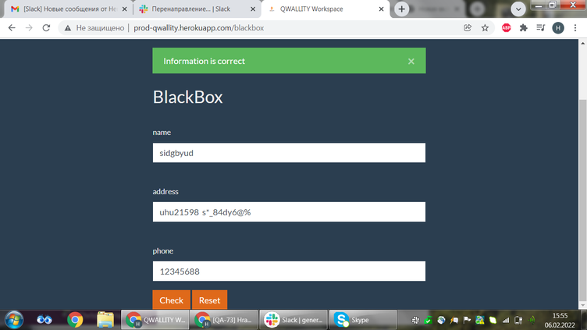

It was tested in <https://qwallity.herokuapp.com/> enviroment. The addres field accepts symbols in Blackbox, bug is not fixed.

